Problem 01: IP Addressing
given IP address: 144.222.12.109/12
determine the network addr, broadcast addr, subnet mask, and valid IP addr range

1001'0000.1101 | 1110.0000'1100.0110'1101
1001'0000.1101 | 0000.0000'0000.0000'0000 net addr --> 144.208.0.0
1001'0000.1101 | 1111.1111'1111.1111'1111 broad addr --> 144.223.255.255
1111'1111.1111 | 0000.0000'0000.0000'0000 subnet mask--> 255.240.0.0

1001'0000.1101 | 0000.0000'0000.0000'0001 smallest valid IP addr --> 144.208.0.1
1001'0000.1101 | 1111.1111'1111.1111'1110 largest valid IP addr --> 144.223.255.254

Problem 2: (20 marks) IP Subnet
Given the network address 192.168.10.0/24, and the following network topology:
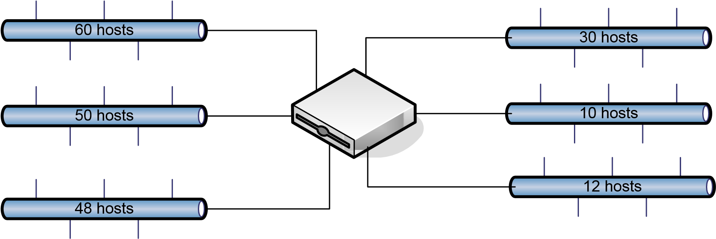
Propose a subnet solution to allocate the network address range: 192.169.10.0/24 into 6 network segments in the above figure.

60 (2⁶), 50 (2⁶), 48 (2⁶), 30 (2⁵), 10 (2⁴), 12 (2⁴)

Block A:
192.168.10.00'00 0000 /26 → 192.168.10.0/26 netaddr
192.168.10.00'00 0001 /26 → 192.168.10.1/26 smallest valid IP
192.168.10.00'11 1110 /26 → 192.168.10.62/26 largest valid IP
192.168.10.00'11 1111 /26 → 192.168.10.63/26 broadcast addr

Block B:
192.168.10.01'00 0000 /26 → 192.168.10.64/26 netaddr
192.168.10.01'00 0001 /26 → 192.168.10.65/26 smallest valid IP
192.168.10.01'11 1110 /26 → 192.168.10.126/26 largest valid IP
192.168.10.01'11 1111 /26 → 192.168.10.127/26 broadcast addr

Block C:
192.168.10.10'00 0000 /26 → 192.168.10.128/26 netaddr
192.168.10.10'00 0001 /26 → 192.168.10.129/26 smallest valid IP
192.168.10.10'11 1110 /26 → 192.168.10.190/26 largest valid IP
192.168.10.10'11 1111 /26 → 192.168.10.191/26 broadcast addr
Block D:
192.168.10.110'0 0000 /27 → 192.168.10.192/27 netaddr
192.168.10.110'0 0001 /27 → 192.168.10.193/27 smallest valid IP
192.168.10.110'1 1110 /27 → 192.168.10.222/27 largest valid IP
192.168.10.110'1 1111 /27 → 192.168.10.223/27 broadcast addr

Block E:
192.168.10.1110' 0000 /28 → 192.168.10.224/28 netaddr
192.168.10.1110' 0001 /28 → 192.168.10.225/28 smallest valid IP
192.168.10.1110' 1110 /28 → 192.168.10.238/28 largest valid IP
192.168.10.1110' 1111 /28 → 192.168.10.239/28 broadcast addr

Block F:
192.168.10.1111'0000 /28 → 192.168.10.240/28 netaddr
192.168.10.1111'0001 /28 → 192.168.10.241/28 smallest valid IP
192.168.10.1111'1110 /28 → 192.168.10.254/28 largest valid IP
192.168.10.1111'1111 /28 → 192.168.10.255/28 broadcast addr

Problem 3: IP Routing Algorithm (Dijkstra Algorithm)
Find the shortest paths from the source node A to the other nodes using Dijkstra’s algorithm. Show all steps towards your solution.
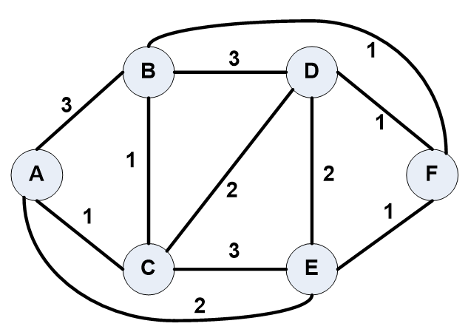

Step | Route | Cost | B | C | D | E | F
0 | A | 0 | 3,A | 1,A | ∞ | 2,A | ∞
1 | AC | 1 | 2,C | * | 3,C | 2,A | ∞
2 | ACB | 2 | * | * | 3,C | 2,A | 3,B
3 | AE | 2 | * | * | 3,C | * | 3,B
4 | ACD | 3 | * | * | * | * | 3,B
5 | ACBF | 3 | * | * | * | * | *

